Mini Project – Dairy product sales analysis in Power BI
Step1:
Insert the Cleaned dataset into PowerBI
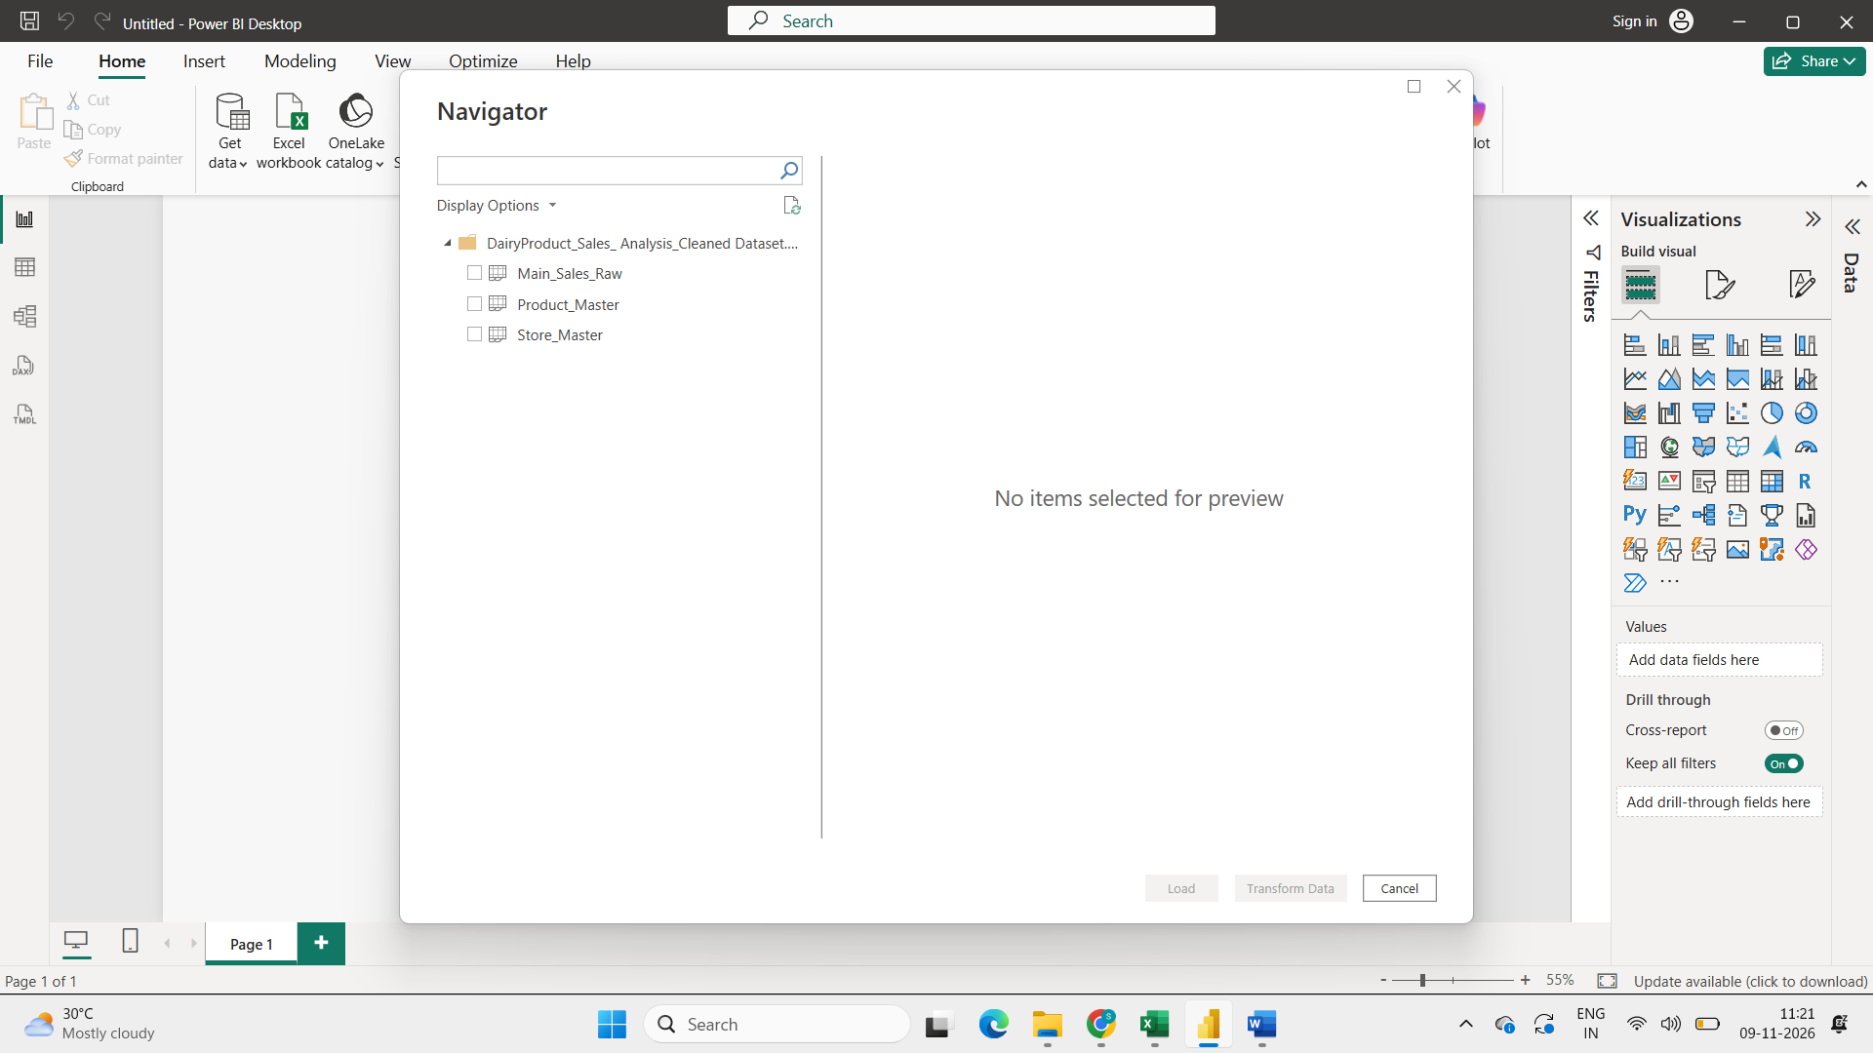
Step2:
Made a connections with Data Modelling
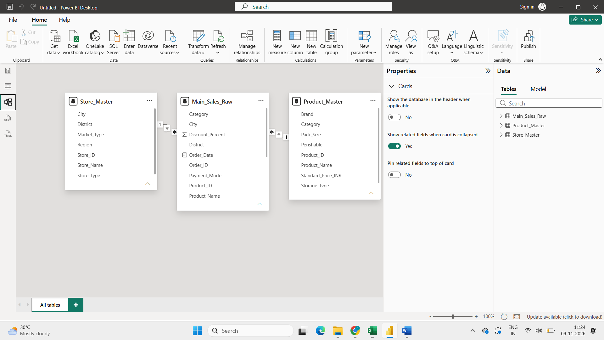

Step3:
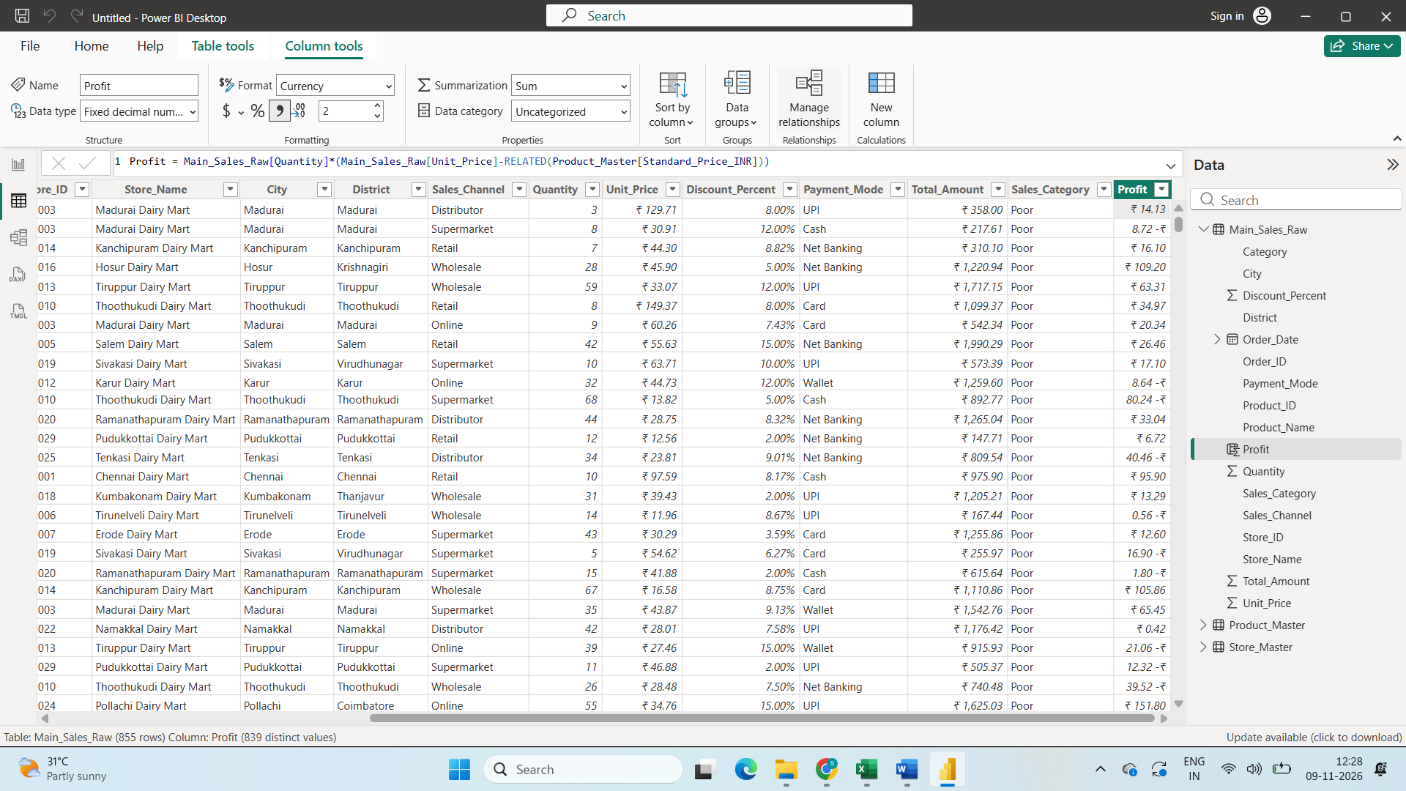Created columun with dax Profit = Main_Sales_Raw[Quantity]*(Main_Sales_Raw[Unit_Price]-RELATED(Product_Master[Standard_Price_INR])) to calculate the profit and loss
Step4:
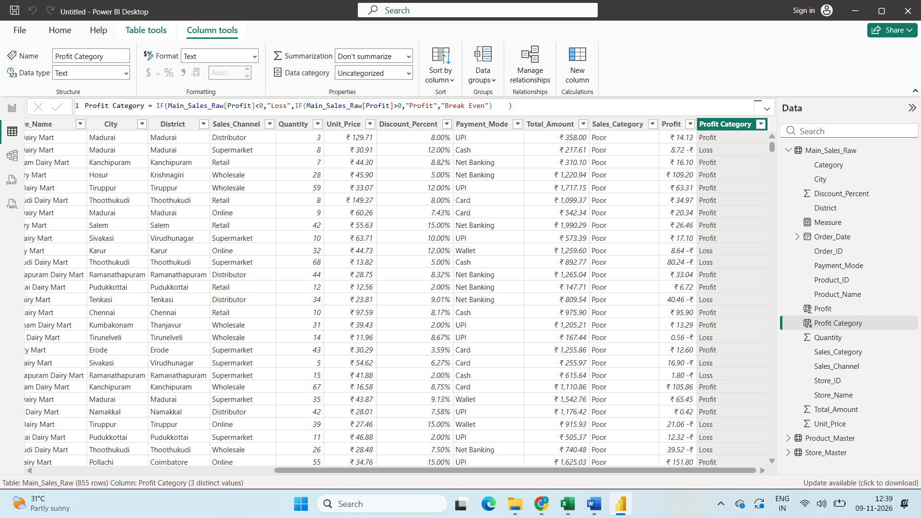

Step4:
Created Custom Column Named Product Category with Dax function
Profit Category = IF(Main_Sales_Raw[Profit]<0,"Loss",IF(Main_Sales_Raw[Profit]>0,"Profit","Break Even") )

Step5:
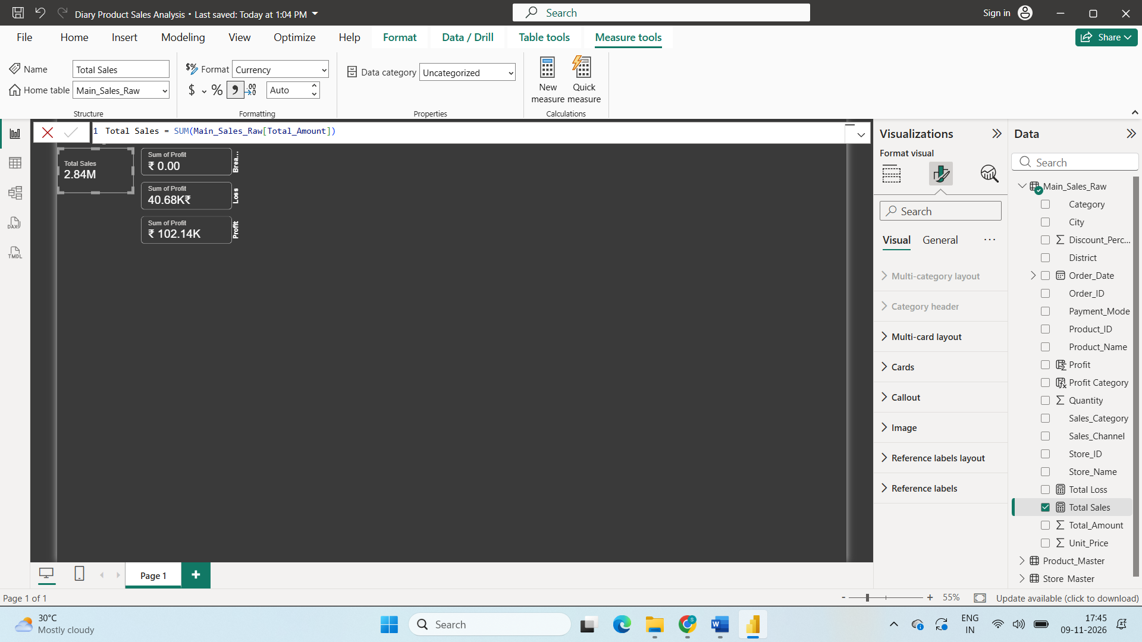
Created New measure with sum of total Amount to calculate total sales and set it into card Visulization.
Step 6:
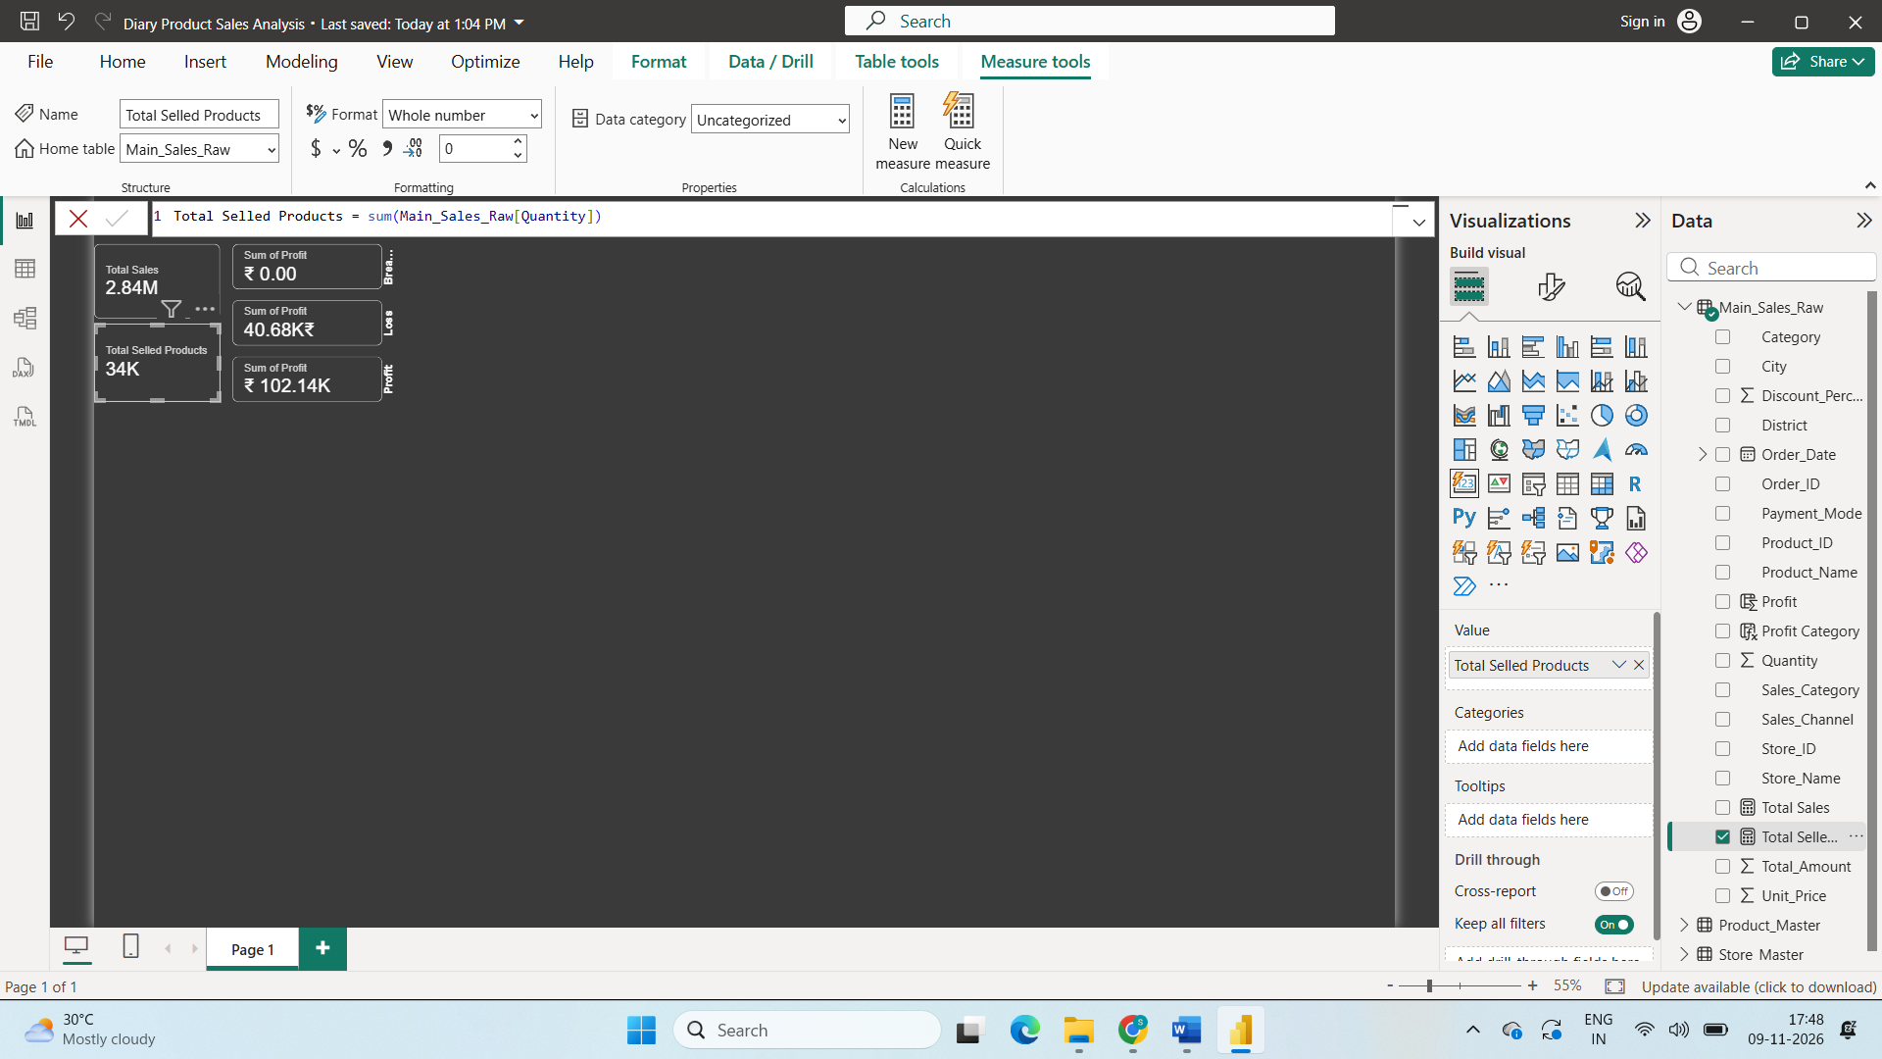
Created New measure with sum of Quantity to calculate total Selled Products and set it into card Visulization.
Step7:
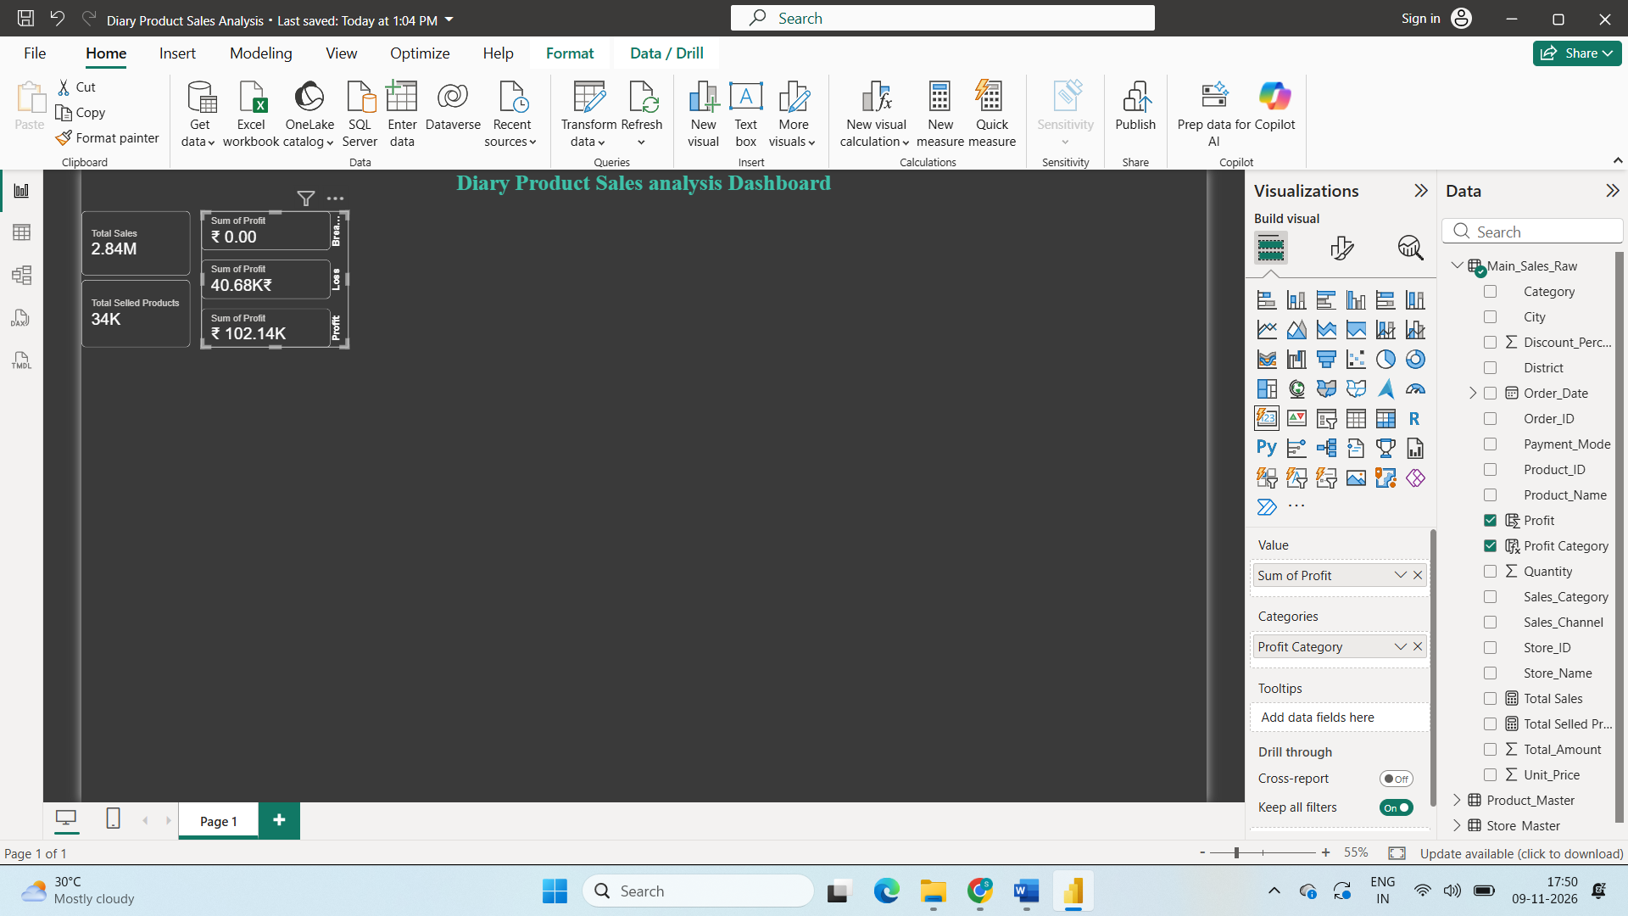
Used Card visualization to Visualize total Profit and Loss.
Step8:
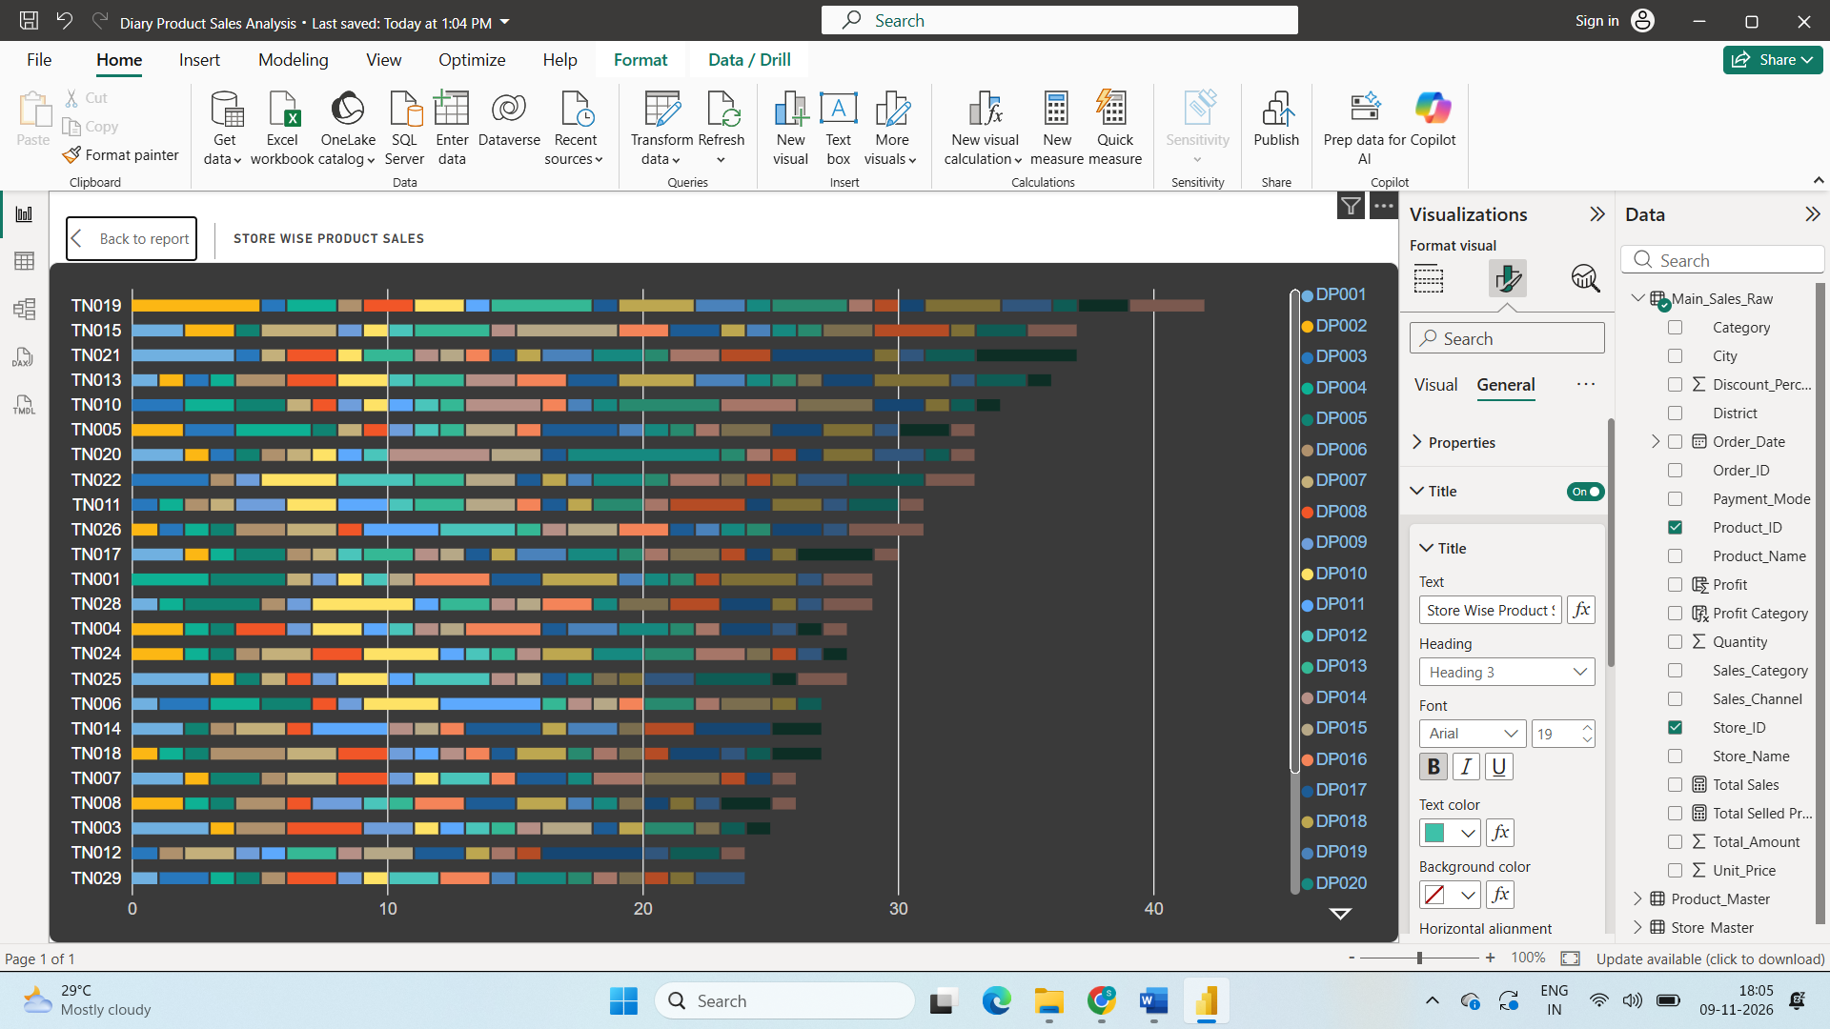
Visualize Store wise Product sales with the Stacked Bar chart
Step 9:
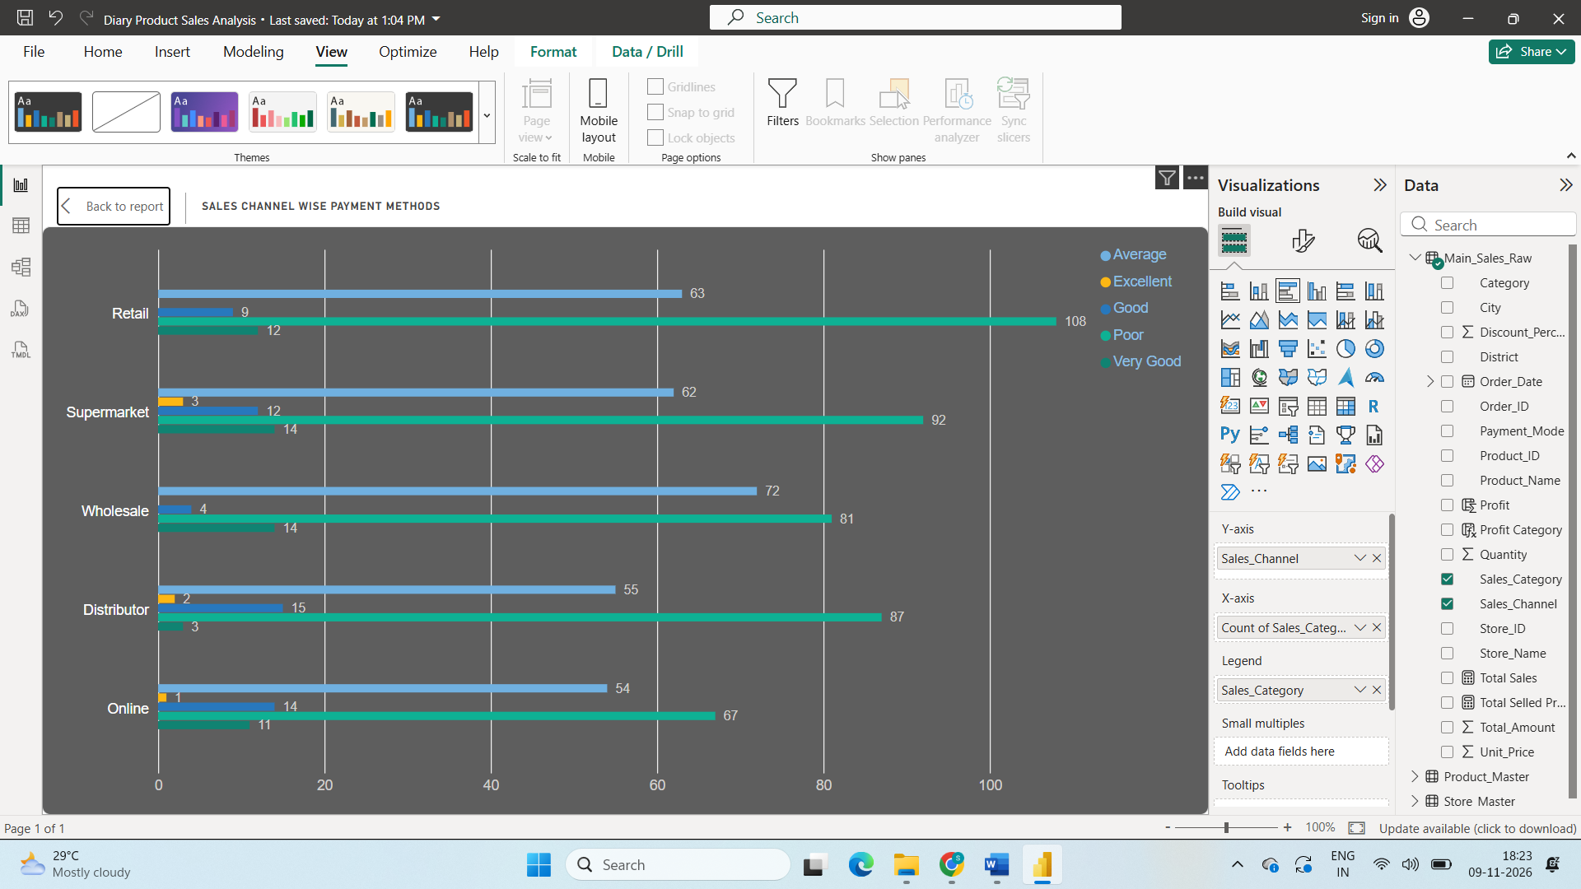
Sales Channel Wise Payment Methods with Clustered Bar chart
Step10:
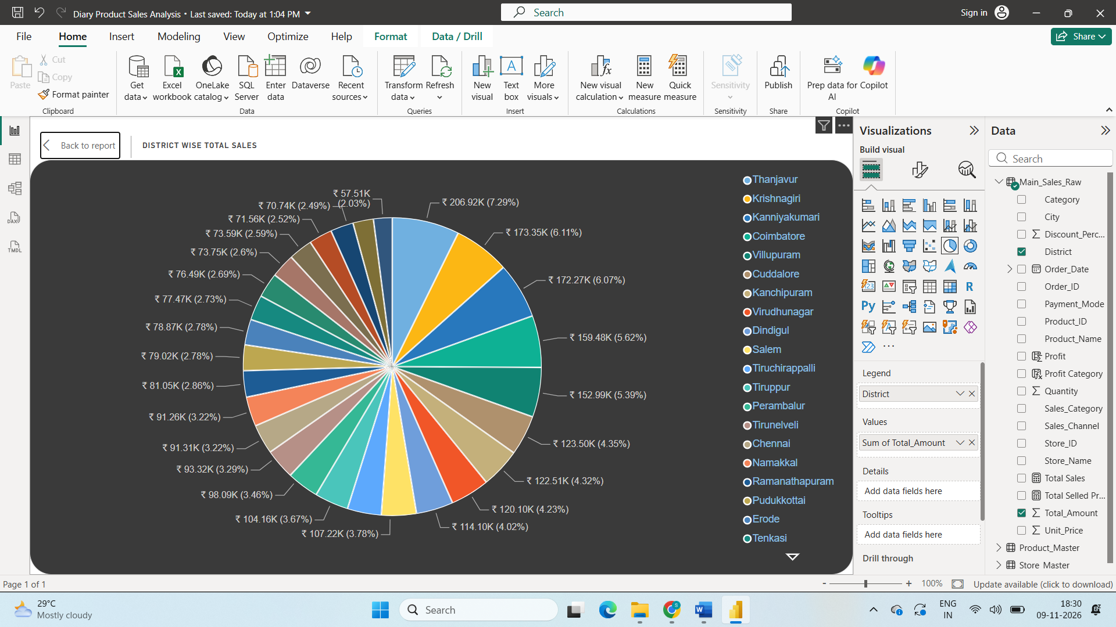
District Wise Total Sales with Pie Chart
Step11:
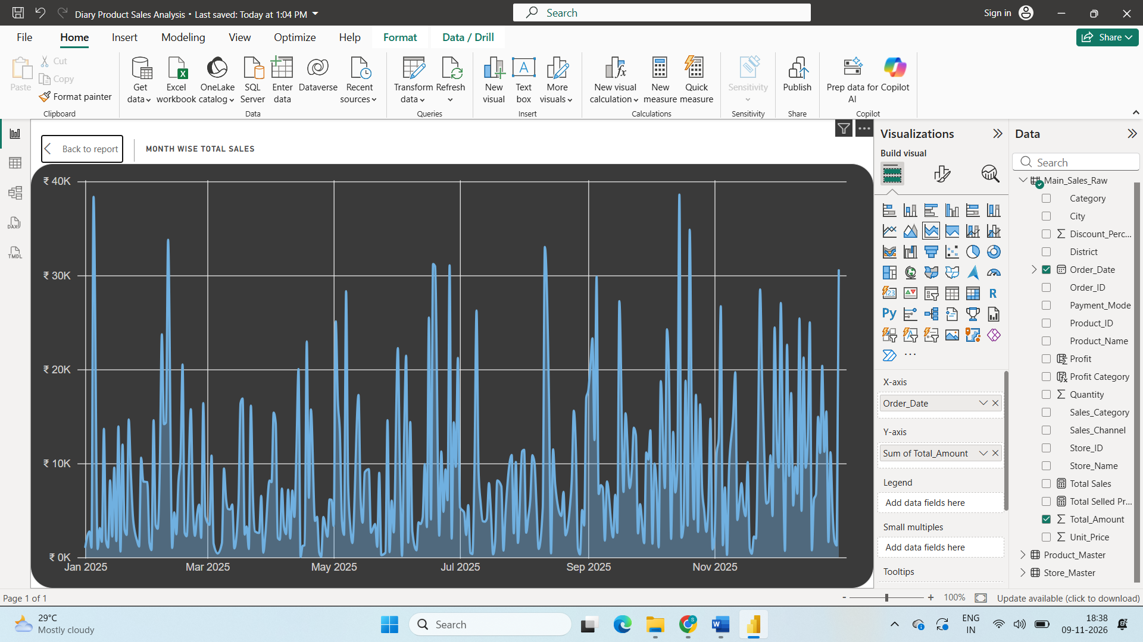
Month Wise Total Sales with Stacked Area chart
Step12:
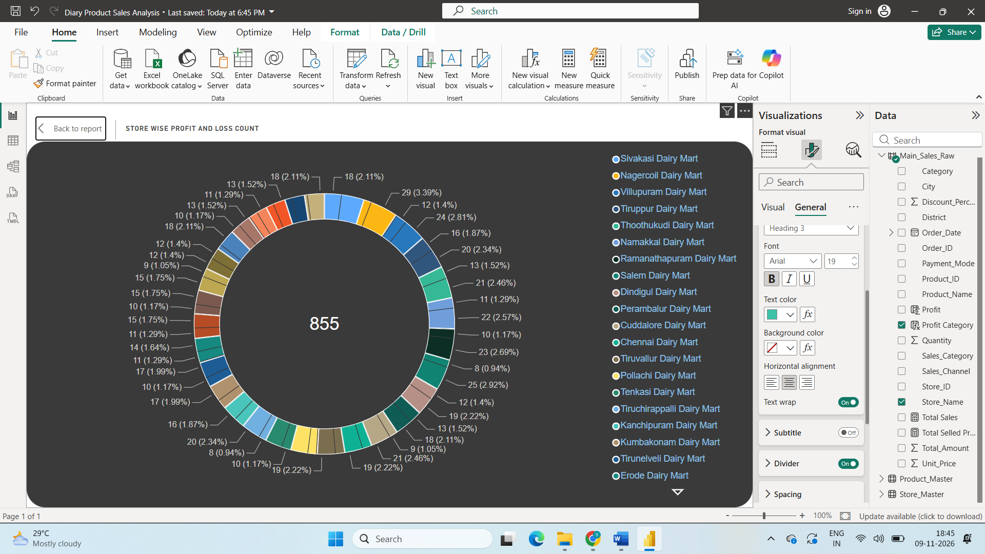
Store Wise Profit and Loss Count with Donut Chart
Step13:
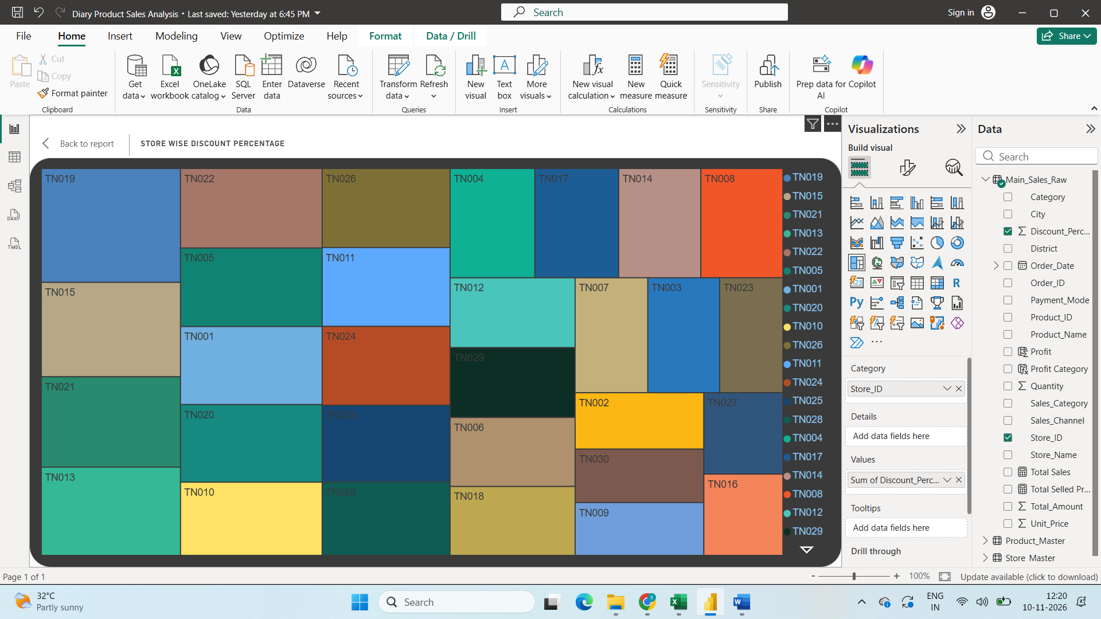
Store wise Discount with Treeamap Chart
Step14:
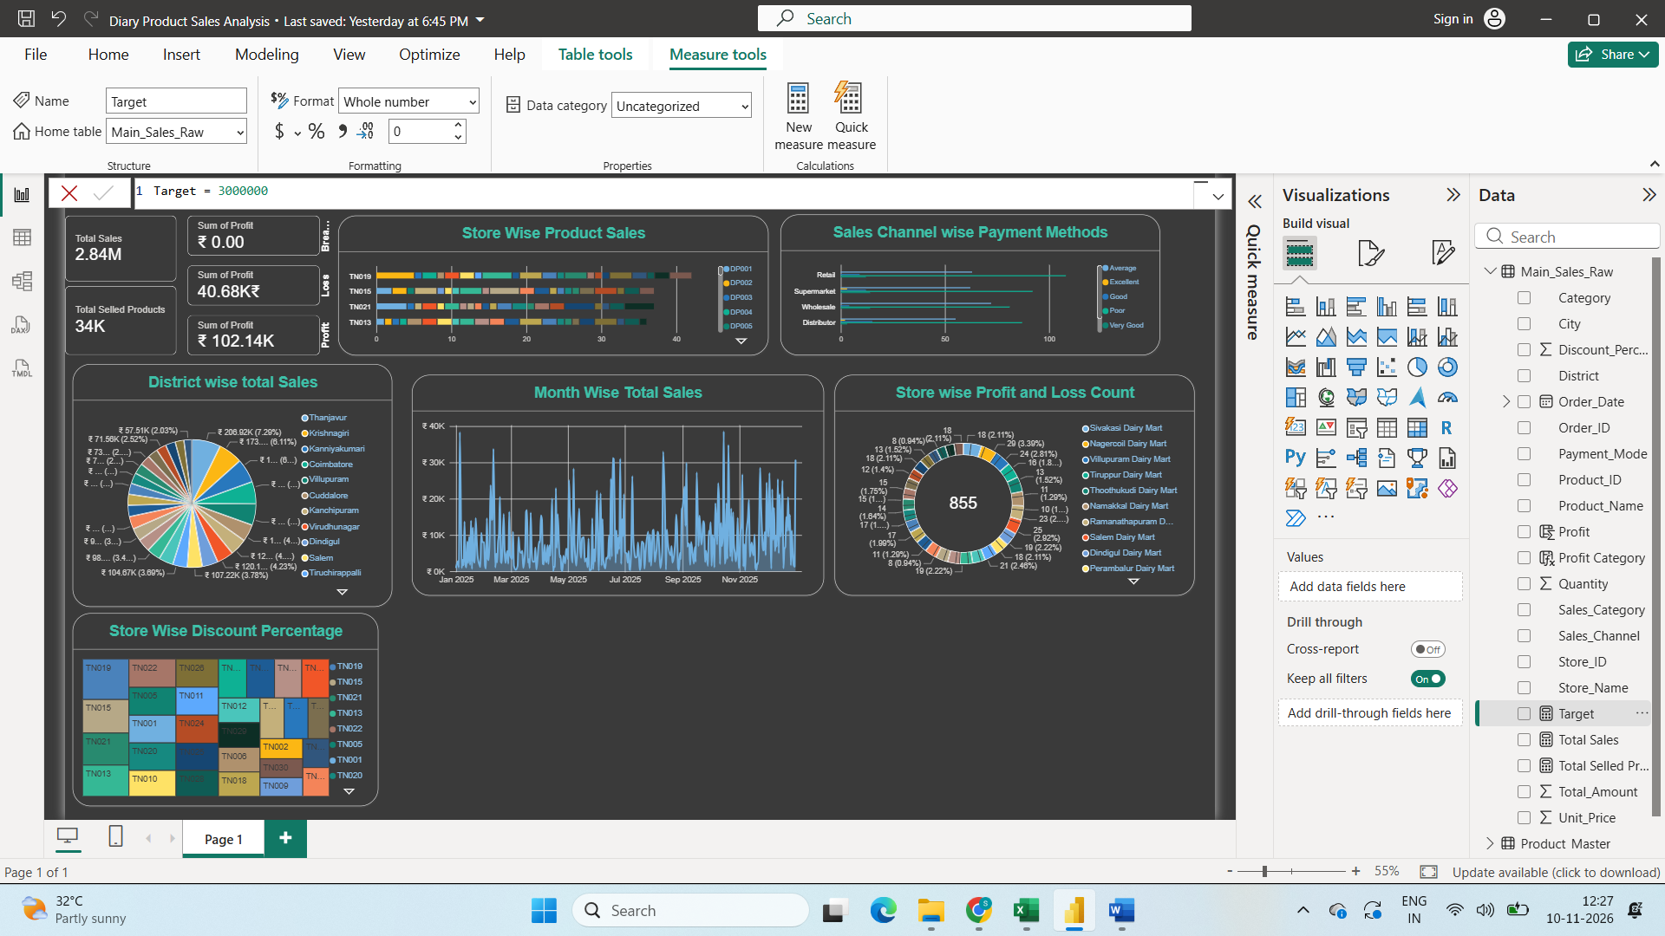
Created new measure named Target
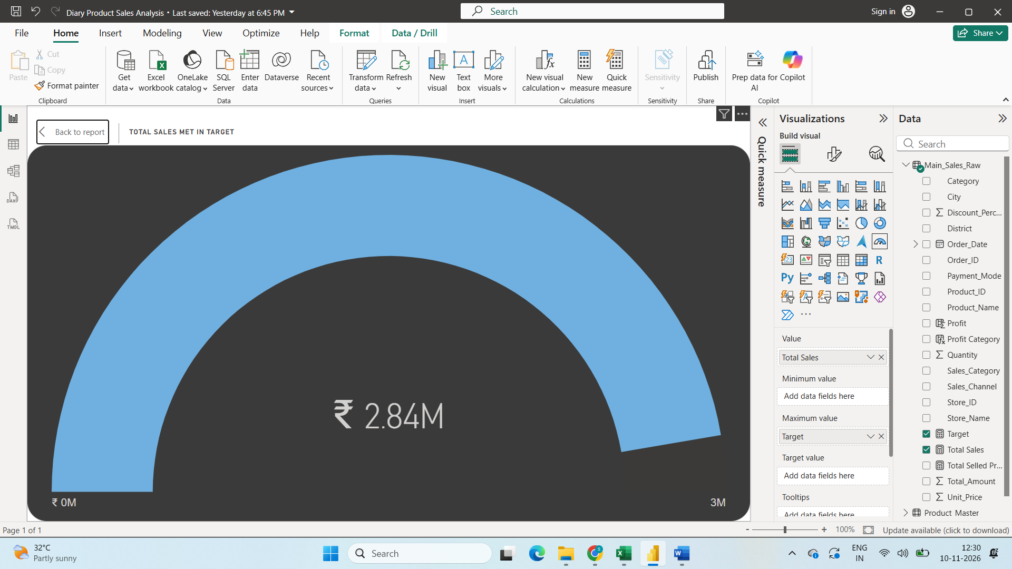
Total Sales Met in Target with Gauge chart
Step15:
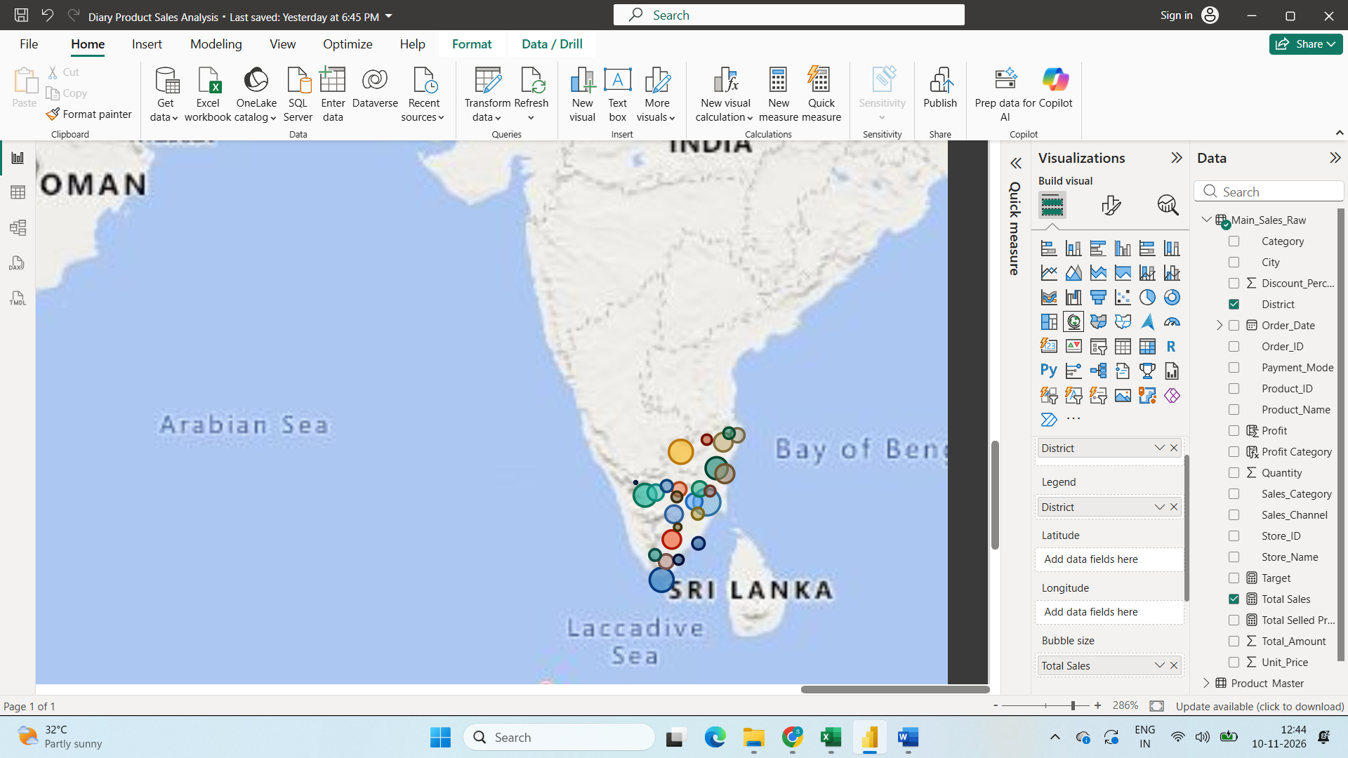District Wise total Sales with Map Chart
Step16:
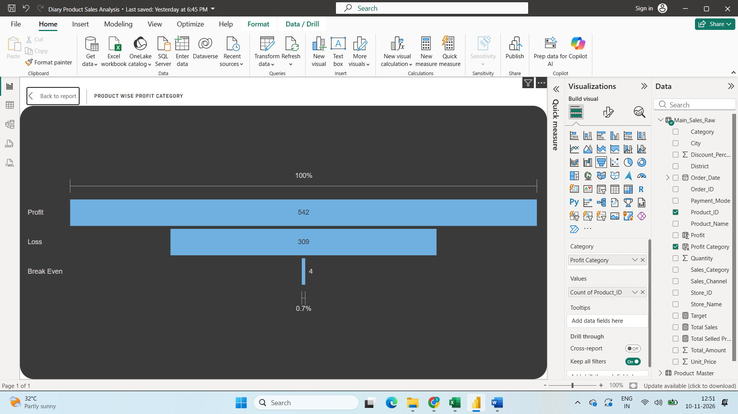
Product Wise Profit and loss with Funnel Chart.
Step17:
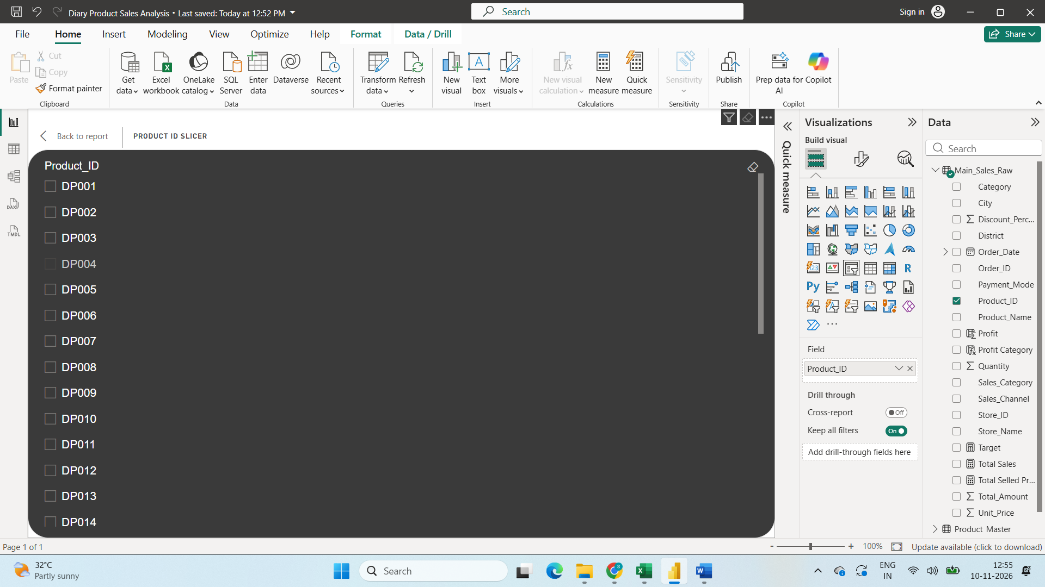
Add a slicer with product ID
Step18:
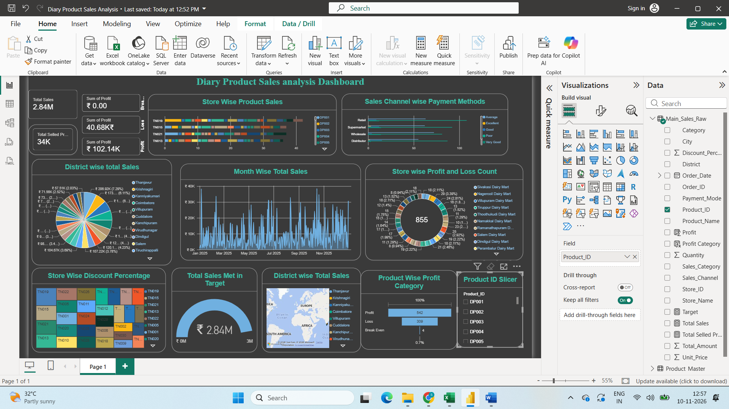
Dashboard for Sales Analysis
Product And Sales Insights
Step1:
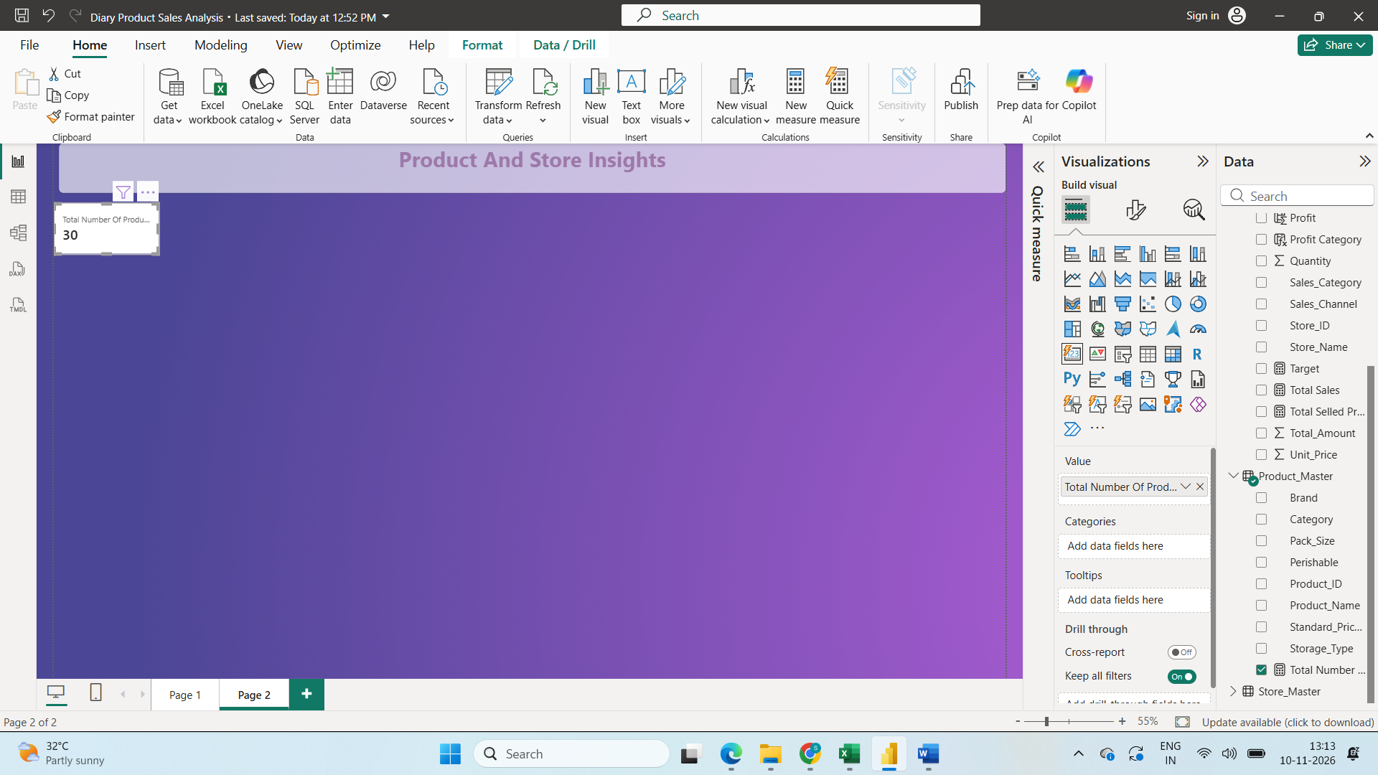
Add a card with total of Products
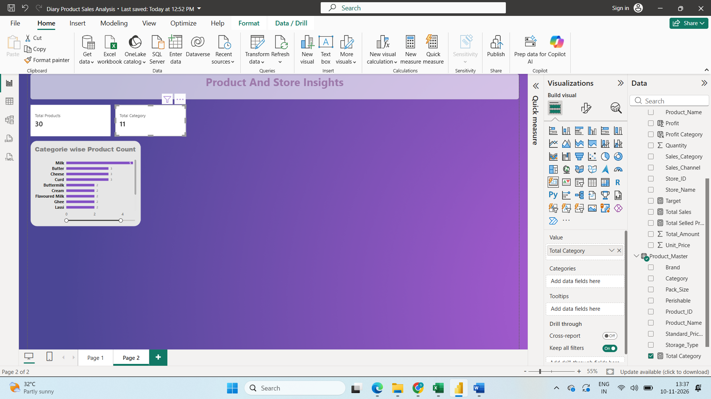
Add a card with total category and also Total stores and Store types
Step2
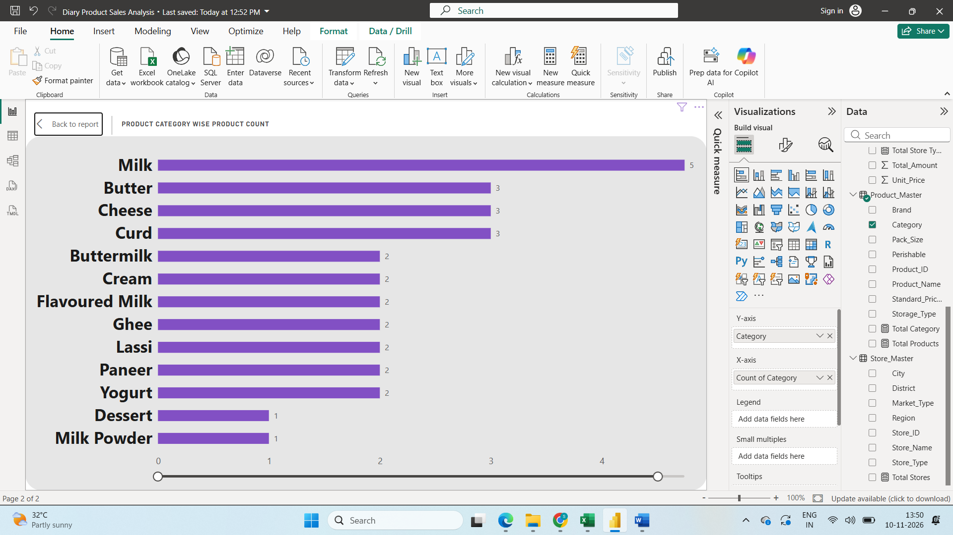
Product Category Wise Product Count in Stacked Bar Chart
Step3:
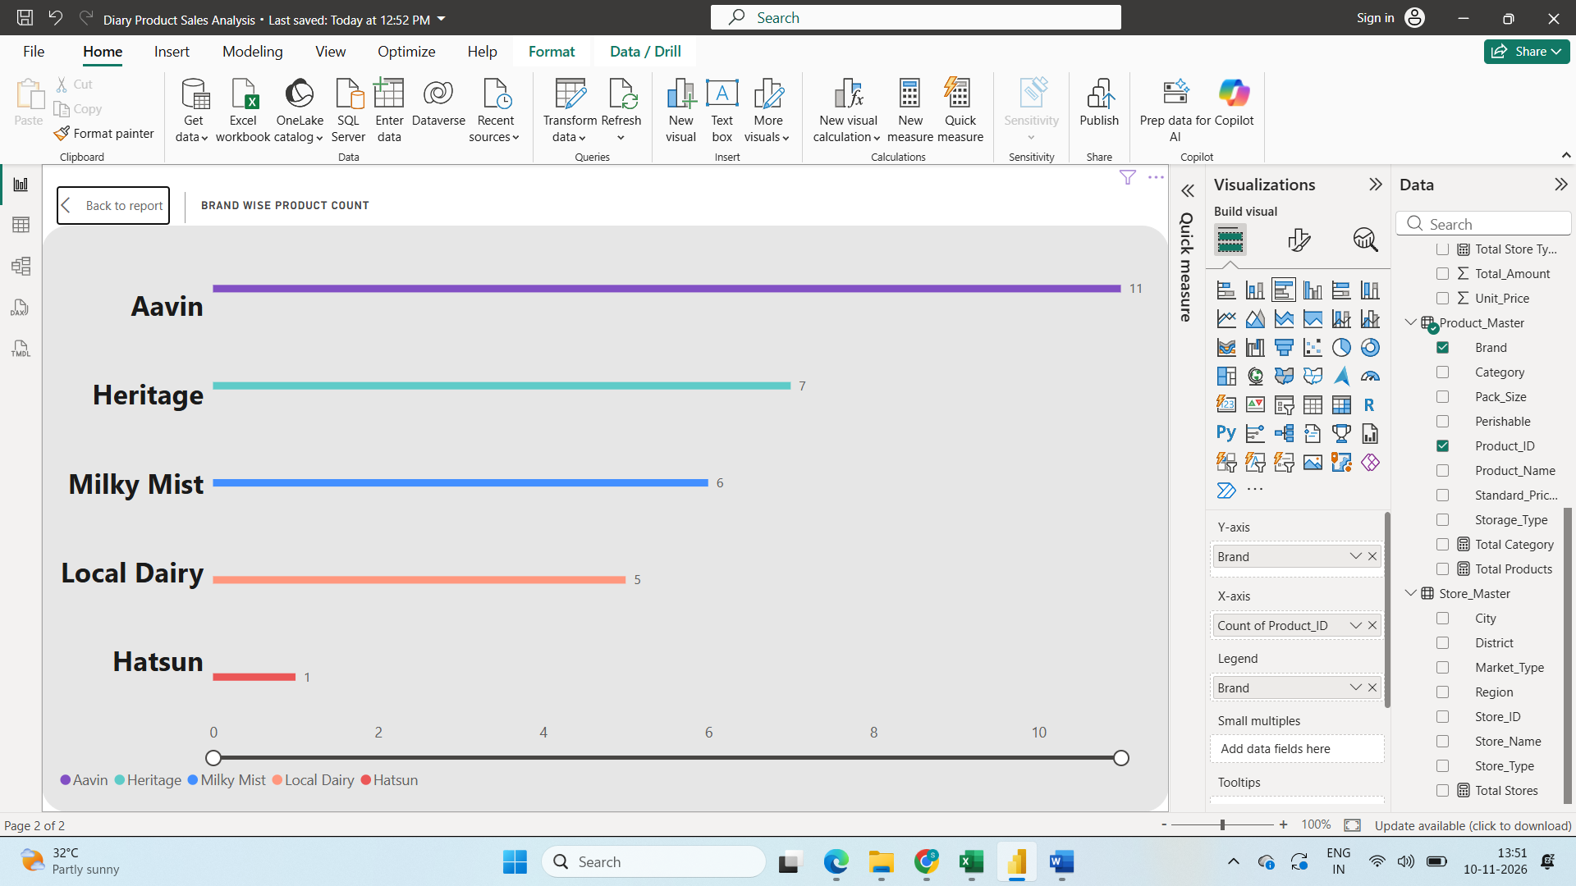
Brand wise product count in Cluster Bar chart
Step3:
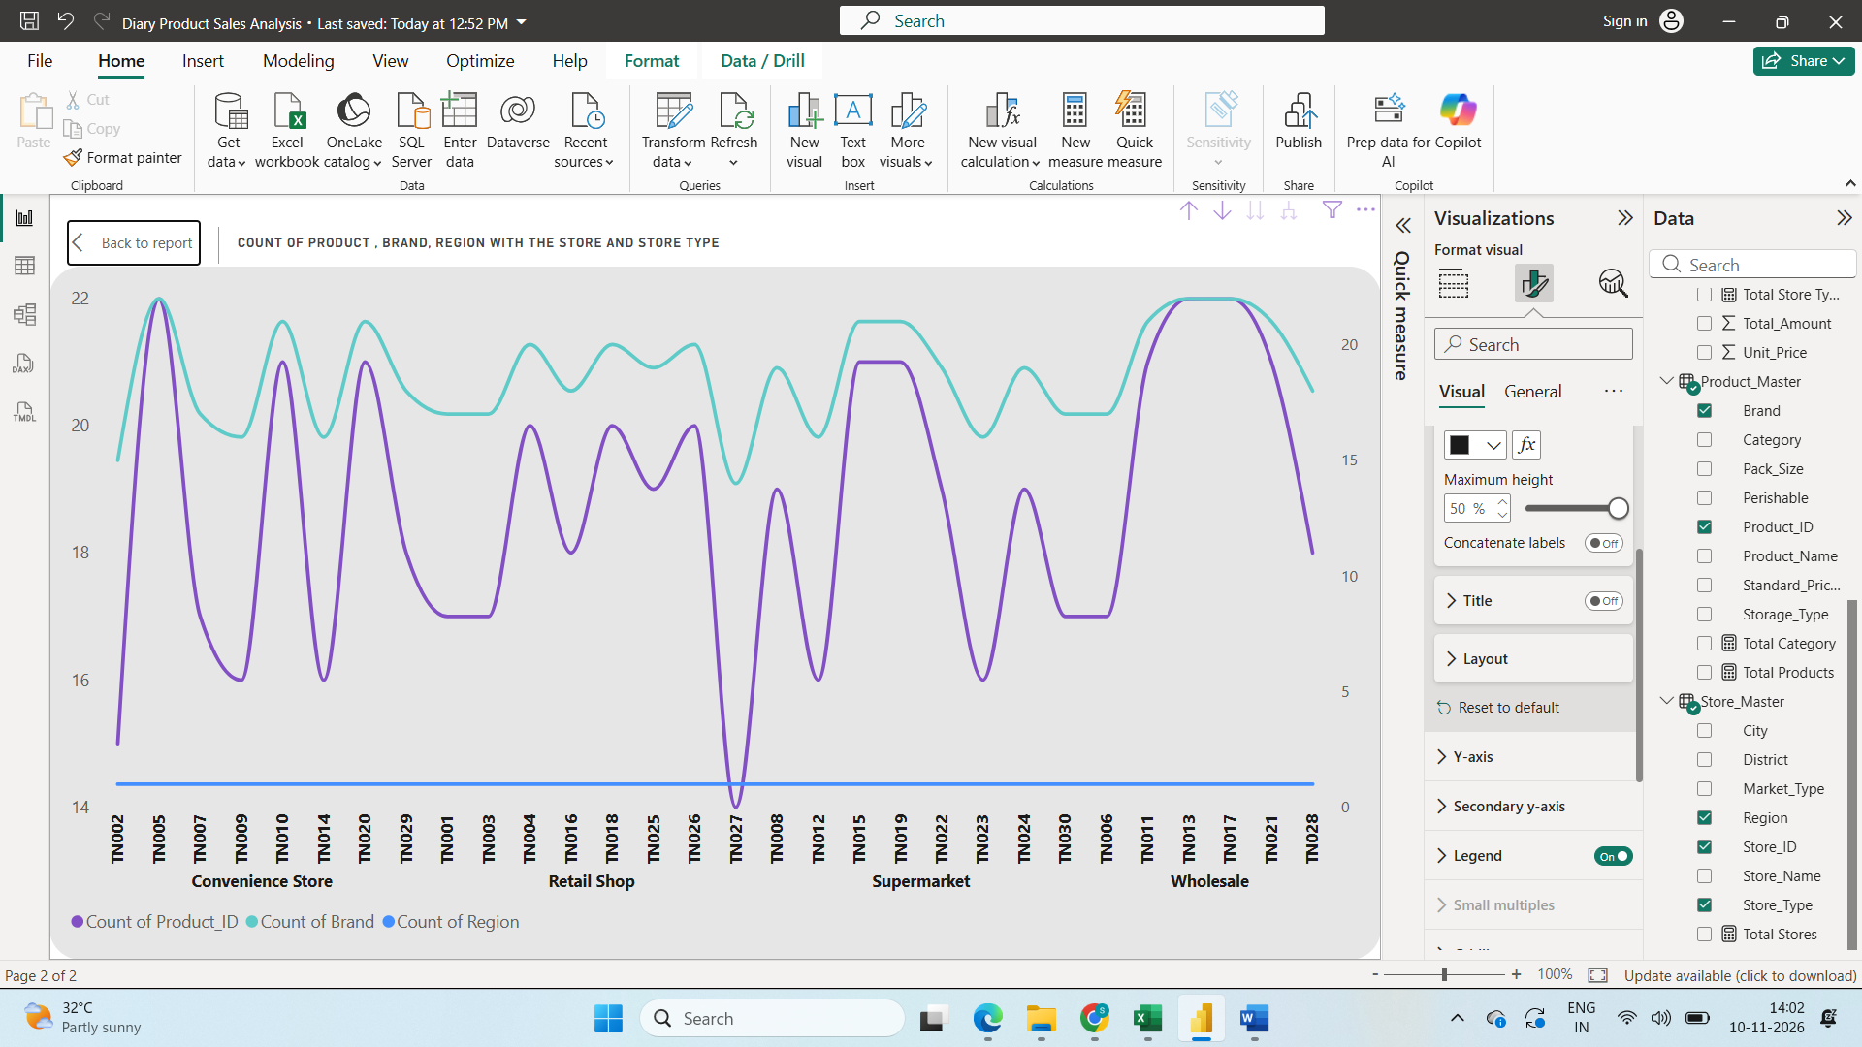
Count of Product, Brand and Region with Store and Store type in line Chart
Step4:
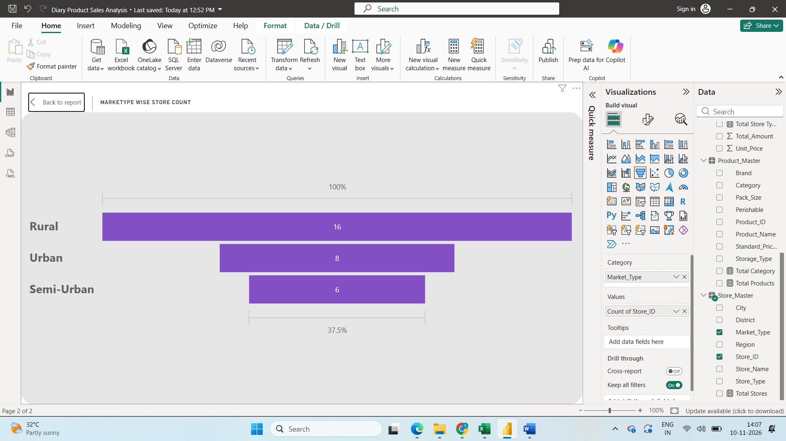
Market Type Wise Store Count in Funnel chart
Step5:
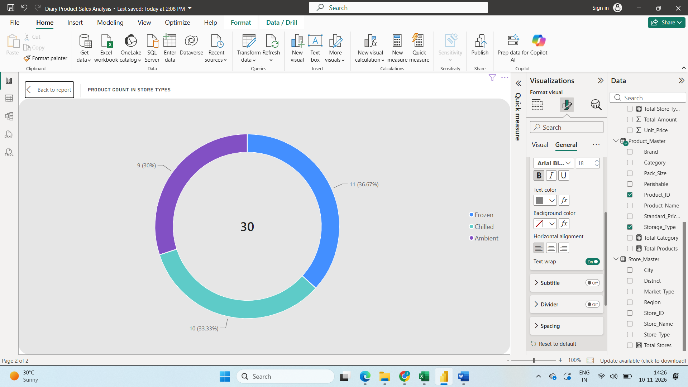
Product Count with Store types in Donut Chart
Step6:
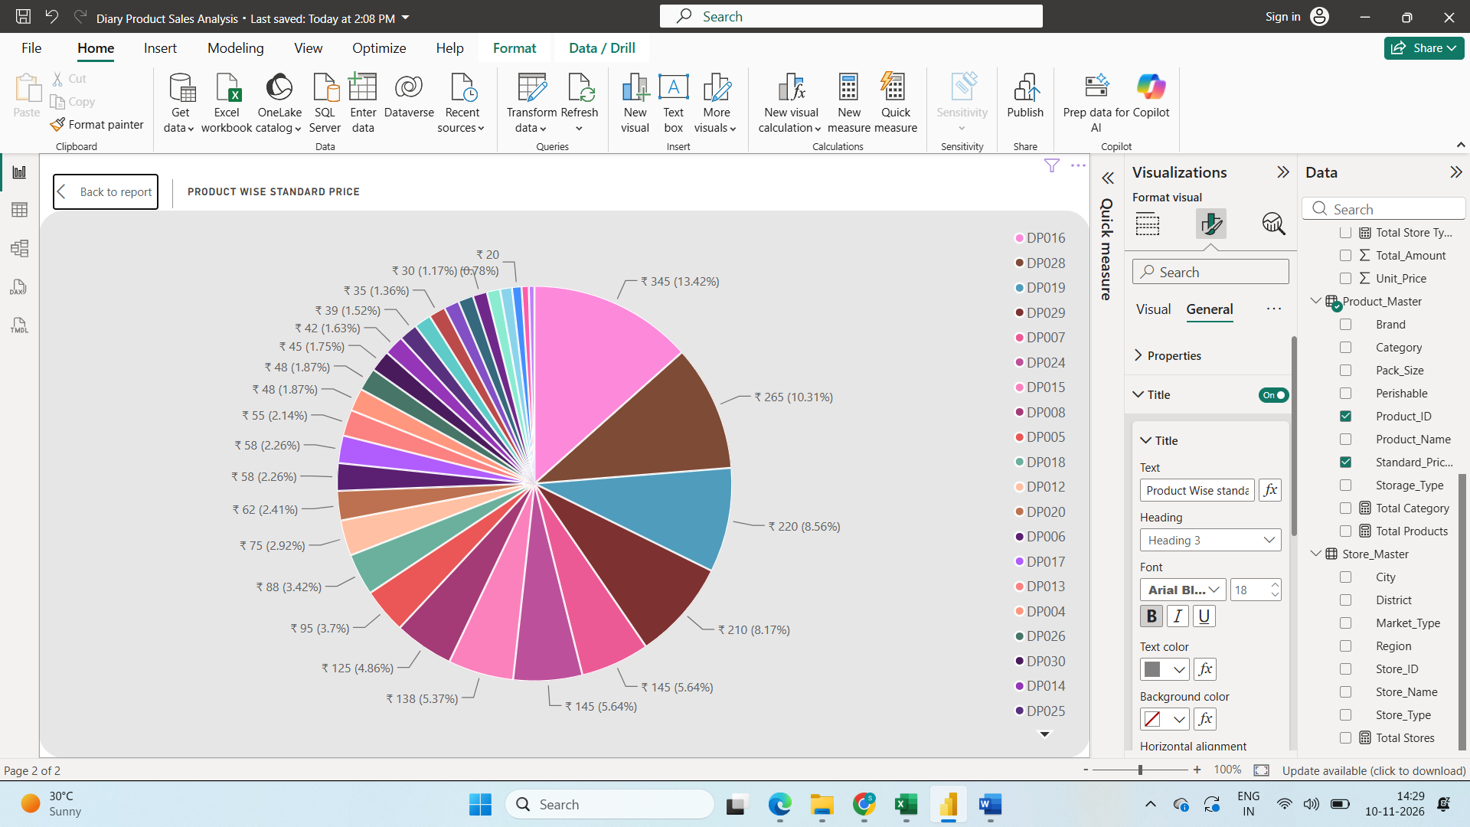
Productwise Standard price in Pie chart
Step7:
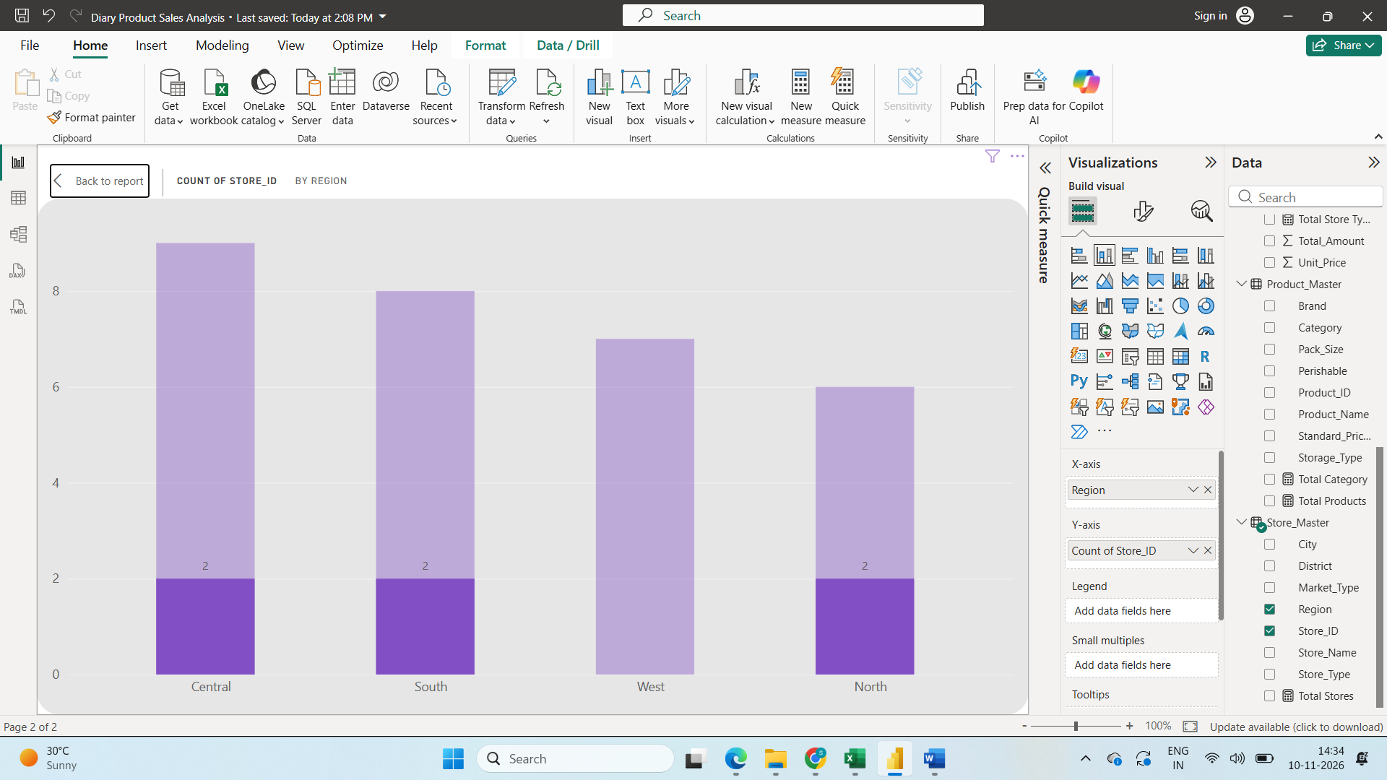
Count of Store ID by Region in Stacked Column Chart
Step8
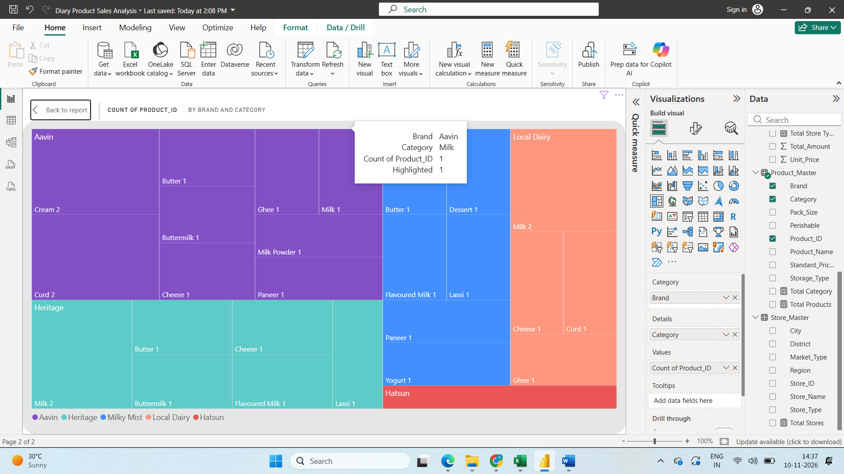
Count of Product in Brand and Category
Step9
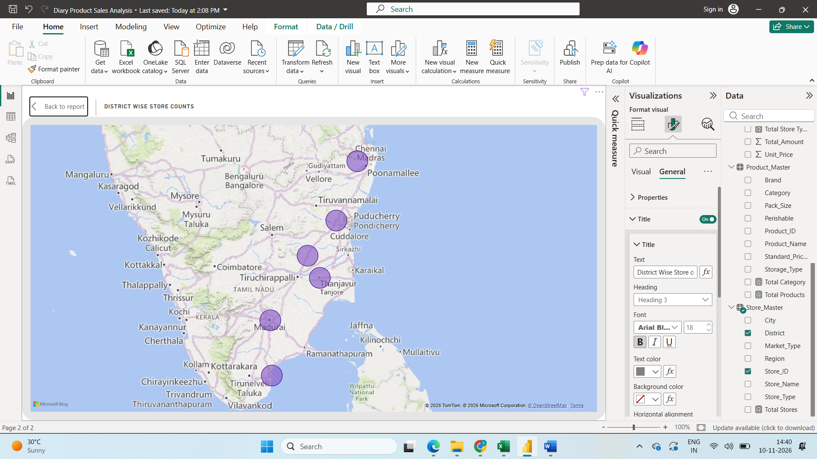
District wise store count in Map Chart
Step10:
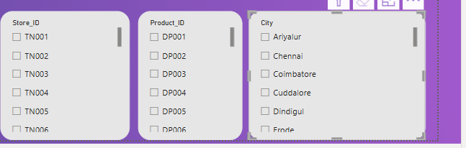
Added Slicer for product , store and City
Step11:
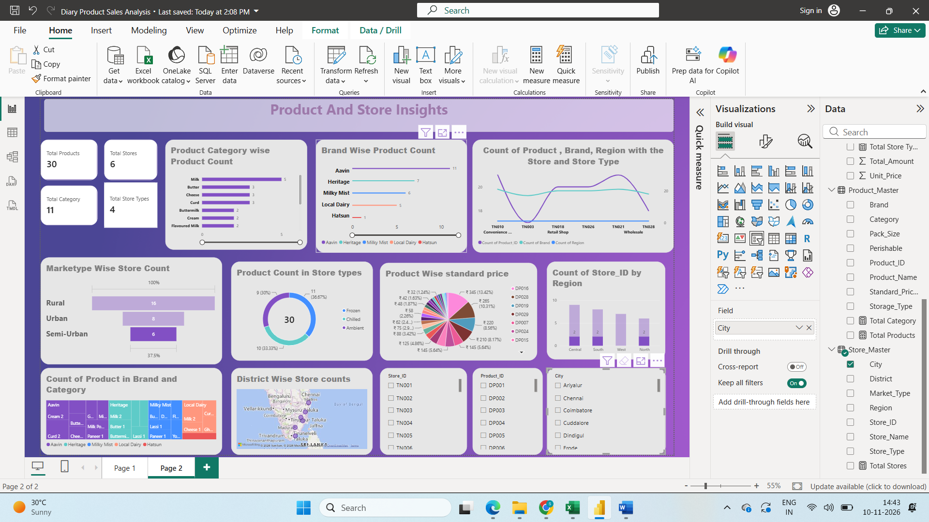
Product And Store Insights Dashboard.

